The Fuzzy sets have 9 membership sets, as given below. The two inputs as well as the output are all divided into 9 sets. In the code they are depicted as numbers from 0-8.

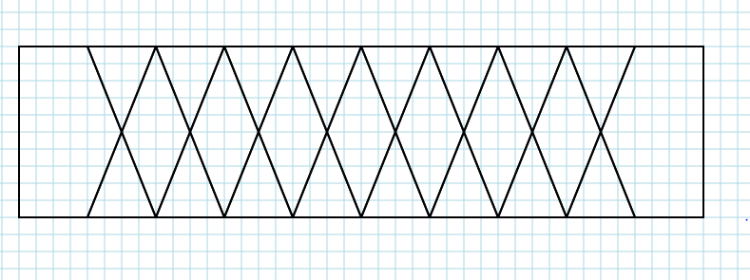

Slightly Low

Low

Very Low

Extremely Low

Extremely High

Very High

Slightly High

High

Mid

-1.0 -0.8 -0.6 -0.4 -0.2 0.0 0.2 0.4 0.6 0.8 1.0

-1.0 -0.8 -0.6 -0.4 -0.2 0.0 0.2 0.4 0.6 0.8 1.0

The Fuzzy Association Matrix is as below

|  |  |  |  |  |  |  |  |  |  |
| --- | --- | --- | --- | --- | --- | --- | --- | --- | --- |
|  | EL | VL | L | SL | M | SH | H | VH | EH |
| EL | EL | EL | VL | L | L | L | SL | SL | M |
| VL | EL | VL | VL | VL | L | L | SL | M | SH |
| L | VL | VL | L | L | L | SL | SL | SL | M |
| SL | L | L | L | L | SL | SL | SL | M | M |
| M  *Inflow in K C* | L | SL | SL | SL | SL | M | SH | SH | SH |
| SH | SL | SL | M | M | M | SH | SH | SH | H |
| H | H | H | H | H | H | VH | VH | EH | EH |
| VH | H | H | H | VH | VH | VH | VH | EH | EH |
| EH | H | H | VH | VH | VH | EH | EH | EH | EH |

Vertical: *Inflow in K Cusecs*

Horizontal: *Height in m*

The contour with the values above is:

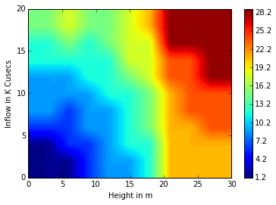

The 3-D plot is :

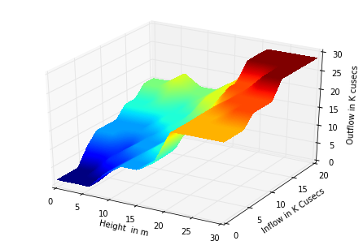 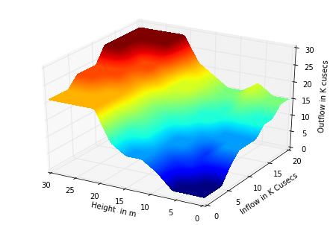

Sample Values:

|  |  |  |
| --- | --- | --- |
| ***Height in m*** | ***Inflow in K Cusecs*** | ***Outflow in K Cusecs*** |
| 0 | 10 | 9.0 |
| 12 | 11 | 12.0 |
| 15 | 15 | 18.0 |
| 24 | 3 | 21.0 |
| 17 | 6 | 14.0 |
| 2 | 14 | 12.0 |
| 28 | 19 | 28.5 |